Storage Design
Azure Data Lake Gen2 Structure
Azure Data Lake Storage Gen2 (ADLS Gen2) is Microsoft's cloud-based storage solution purpose-built for big data analytics. It combines the capabilities of Azure Blob Storage with a true hierarchical file system, giving it both massive scalability and file-system-like organization.
How it's organized:
ADLS Gen2 is built around three tiers of organization — the Storage Account at the top, which is the root container for everything; Containers (also called filesystems) sitting beneath it, which act like top-level buckets that logically separate datasets (e.g., one container for raw data, another for processed data); and Directories and Files inside those containers, organized in a tree-like folder structure just like a local hard drive.
A typical data lakehouse structure looks like this:
Storage Account
│
├── raw/ ← Container (filesystem)
│ ├── sales/2024/01/data.csv
│ └── logs/2024/01/app.log
│
├── curated/ ← Container
│ └── sales/aggregated.parquet
│
└── archive/ ← Container
└── sales/2022/old_data.csv
Key capabilities of ADLS Gen2:
ADLS Gen2 supports role-based access control (RBAC) and POSIX-compliant ACLs (Access Control Lists), meaning you can set fine-grained permissions at the file or directory level — not just at the container level. This is critical for enterprise data governance. It also natively integrates with analytics engines like Azure Synapse, Databricks, and HDInsight, and supports the Hadoop Distributed File System (HDFS) protocol, so big data tools can interact with it as if it were a local filesystem.

Hierarchical vs. Flat File Systems
This distinction is fundamental to understanding why ADLS Gen2 is designed the way it is.
Flat File Systems store all files in a single, unstructured namespace. There are no real folders — what appear to be "folders" are just prefixes embedded in the file name (e.g., sales/2024/jan/data.csv is just one long filename). Azure Blob Storage (the predecessor to ADLS Gen2) works this way. The system has no true awareness of directory structure, so operations like "rename a folder" or "list all files in a directory" require scanning every object in the store — which becomes extremely expensive at scale.
Hierarchical File Systems maintain a true directory tree, where folders are real, first-class objects managed by the system itself. ADLS Gen2 introduces this via the Hierarchical Namespace (HNS) feature. Because the filesystem genuinely tracks directories, it can perform operations like renaming or deleting an entire folder in O(1) time (a single atomic operation) rather than having to touch every file individually.
Aspect | Flat File System (Blob) | Hierarchical (ADLS Gen2)
Folder concept | Simulated via prefixes | Real, tracked directories
Rename a folder | Copy + delete every file | Single atomic operation
Directory listing | Prefix scan (slow at scale) | Direct lookup (fast)
ACL permissions | Container or blob level only | Per file and per directory
Analytics performance | Slower for complex queries | Optimized for big data engines
Cost of refactoring data | High (rewrite all paths) | Low (rename directories)
Why this matters in practice: In a data pipeline, raw data is constantly being moved, renamed, and reorganized as it flows through bronze → silver → gold layers. With a flat system, renaming a "folder" of 10 million files means 10 million copy-and-delete operations. With a hierarchical namespace, it's one rename call — dramatically reducing latency, cost, and the risk of partial failures mid-operation.

Summary
ADLS Gen2's hierarchical namespace is what elevates it from a simple object store to a true data lake platform. It gives you the scale of cloud blob storage with the semantics of a proper filesystem — enabling efficient data organization, fine-grained security, and fast metadata operations that flat storage simply cannot match at enterprise scale.

ETL vs. ELT Architecture

The Core Distinction
Both are data integration patterns that move data from sources into a destination system, but they differ in where the transformation happens.
ETL (Extract → Transform → Load) transforms data before it reaches the destination. Raw data is pulled from the source, cleaned and reshaped in an intermediate processing engine, and only the final, structured result is loaded into the target (typically a data warehouse).
ELT (Extract → Load → Transform) loads raw data into the destination first, then transforms it in-place using the compute power of the target system (typically a cloud data lake or warehouse like Snowflake, BigQuery, or Synapse).
ETL: Source → [Extract] → [Transform] → [Load] → Data Warehouse
ELT: Source → [Extract] → [Load] → Data Lake/Warehouse → [Transform]

Design Strategies
ETL Design Principles
ETL was born in an era of on-premise data warehouses with limited storage and compute. The philosophy is only store what you need, already shaped the way you need it. This means:
- Transformation logic lives in a dedicated middleware layer (e.g., SSIS, Informatica, Apache Spark jobs)
- The warehouse receives clean, schema-conformant data only
- Business rules are enforced before persistence, making the warehouse a single source of truth
- Best suited for highly regulated industries (finance, healthcare) where raw data may not be permitted to land in the warehouse at all
ELT Design Principles
ELT is the modern cloud-native approach, enabled by cheap storage and massively scalable query engines. The philosophy is store everything first, transform on demand. This means:
- Raw data lands as-is into a staging zone (bronze layer), preserving full fidelity and history
- Transformations happen using SQL or frameworks like dbt running inside the data platform
- You can re-transform historical data any time business logic changes, without re-ingesting from the source
- Ideal when source schemas evolve frequently or when you want to support multiple downstream use cases from the same raw data
Factor | ETL | ELT
Where transformation runs | External middleware | Inside the target system
Storage of raw data | Not stored (discarded after transform) | Always persisted
Schema flexibility | Schema-on-write (defined upfront) | Schema-on-read (defined at query time)
Latency | Higher (transform is a bottleneck) | Lower (load is fast, transform deferred)
Re-processing historical data | Expensive or impossible | Easy (raw data always available)
Tooling | SSIS, Informatica, Talend | dbt, Spark SQL, Synapse Pipelines
Best for | Structured, regulated, predictable data | Large-scale, diverse, exploratory workloads

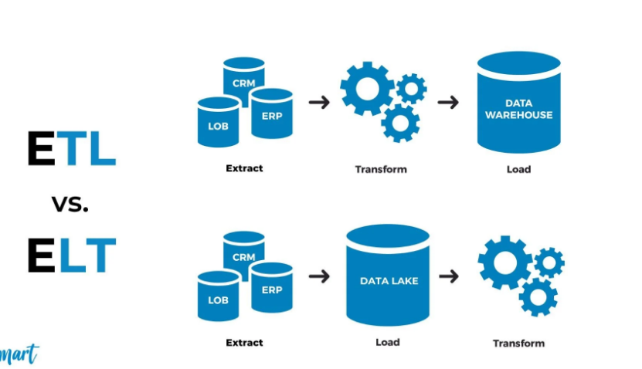

Loading Patterns
Regardless of ETL or ELT, how data is physically moved matters enormously at scale.
Full Load — the entire dataset is replaced on every run. Simple to implement but expensive. Used only for small, slowly-changing reference tables.
Incremental Load — only new or changed records since the last run are pulled. Far more efficient. Requires a reliable change signal such as a last_modified timestamp or a monotonically increasing ID.
Change Data Capture (CDC) — instead of querying the source table, CDC taps into the database's transaction log (e.g., Postgres WAL, SQL Server CDC) to stream every insert, update, and delete in near-real-time. This is the gold standard for high-frequency operational data.
Micro-batch vs. Streaming — micro-batch (e.g., every 5 minutes via Spark Structured Streaming or Azure Data Factory triggers) balances latency and throughput. True streaming (e.g., Kafka + Flink) processes events record-by-record as they arrive, necessary for sub-second SLAs.
Upsert / Merge Pattern — on load, incoming records are matched against existing records by a key. Matching records are updated; new records are inserted. This is the most common incremental loading mechanism in SQL-based ELT (SQL MERGE statement or Delta Lake MERGE INTO).

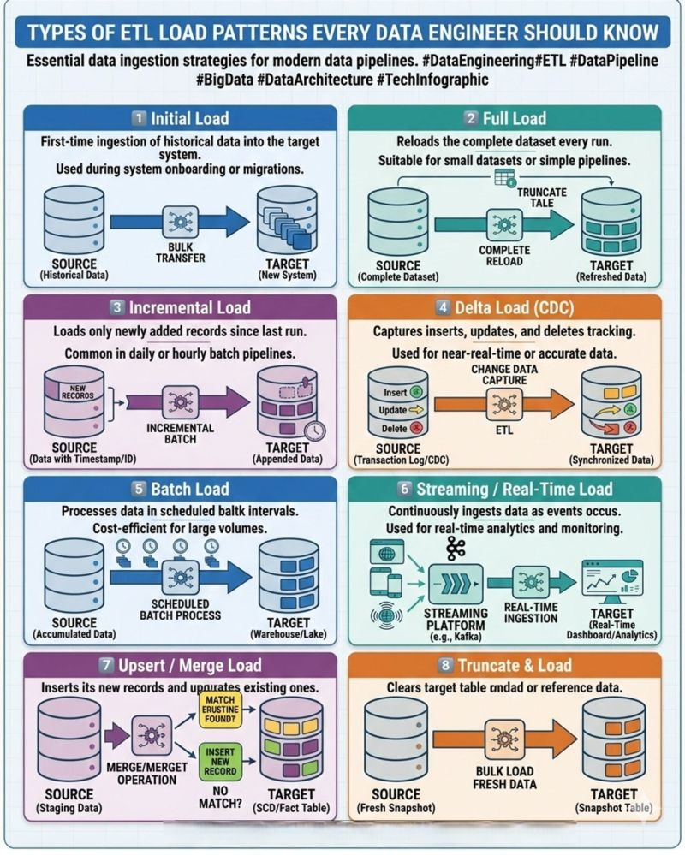

Data Quality Checks
Data quality gates are non-negotiable in any production pipeline. Where you place them differs between ETL and ELT.
In ETL, quality checks run before loading — bad data is rejected and the load never happens, protecting the warehouse. This is more rigid but safer.
In ELT, quality checks run after loading into the raw layer, before promoting data to curated layers — giving you visibility into what arrived before deciding what to do with it.
Common quality dimensions checked:
Completeness — are mandatory fields null? Are expected row counts present?
sql
SELECT COUNT(*) FROM raw.orders WHERE customer_id IS NULL;
Freshness — is the data stale? Did the source system fail to deliver?
sql
SELECT MAX(event_time) FROM raw.events -- should be within last 30 minutes
Referential Integrity — do foreign keys resolve to valid parent records?
sql
SELECT COUNT(*) FROM orders o
LEFT JOIN customers c ON o.customer_id = c.id
WHERE c.id IS NULL -- orphaned orders
Schema Drift Detection — did the source add, remove, or rename columns unexpectedly? Tools like Great Expectations, dbt tests, and Soda Core automate this.
Statistical / Distribution Checks — is the average order value suddenly 10x higher? Are there unexpected spikes in null rates? Anomaly detection catches silent data corruption that row-count checks miss.
A mature pipeline implements a quarantine pattern — records that fail quality checks are routed to a separate bad-records table rather than dropped, so they can be inspected, corrected, and reprocessed.

Handling Unstructured and Semi-Structured Formats
Modern pipelines deal with far more than clean relational tables. Three broad categories exist:
Structured — fixed schema, tabular (CSV, Parquet, relational DB tables). Easiest to process.
Semi-Structured — self-describing but variable schema (JSON, XML, Avro, Parquet with nested types). The most common format in modern APIs and event streams.
Unstructured — no inherent schema (images, PDFs, audio, free-form text logs). Requires AI/ML to extract meaning.

Handling Semi-Structured Data (JSON / XML)
JSON is the dominant format for API responses and event streams. The challenge is that JSON can be deeply nested, have optional fields, and change shape over time.
In ELT pipelines, most cloud warehouses (Snowflake, BigQuery, Synapse) can store raw JSON in a native semi-structured column type and parse it using SQL at query time:
sql
-- Snowflake example: parse JSON stored in a VARIANT column
SELECT
raw_payload:user.id::STRING AS user_id,
raw_payload:event.type::STRING AS event_type,
raw_payload:metadata.timestamp::TIMESTAMP AS event_time
FROM raw.events;
Schema evolution is handled by preserving the full raw JSON and only parsing the fields you need when you need them — meaning new fields added by the source don't break your pipeline.
For XML, tools like Azure Data Factory's XML connector or PySpark's spark-xml library parse the hierarchy into DataFrames, which can then be flattened and written to columnar formats.

Handling Unstructured Data
Unstructured data cannot be queried directly. The standard approach is a feature extraction pipeline:
- PDFs and documents → text extraction (Apache Tika, Azure Form Recognizer) → store extracted text and metadata in a structured table
- Images → computer vision models → tags, classifications, bounding boxes stored as structured rows
- Audio/video → transcription (Whisper, Azure Speech) → transcript text stored as structured data
- Free-form logs → regex parsing or LLM-based extraction → structured events
The raw binary files are always stored in the data lake (e.g., as blobs in ADLS Gen2), and the extracted features are stored in a queryable layer alongside them, linked by a file ID.

Format Optimization: Parquet and Delta Lake
Regardless of how data arrives, it is almost always converted to Parquet or Delta Lake format before analytical use, because:
- Parquet is columnar — queries that touch only a few columns skip the rest entirely, reducing I/O by orders of magnitude
- Delta Lake adds ACID transactions, schema enforcement, and time-travel (the ability to query data as it existed at any past point) on top of Parquet
- Both support partition pruning — if data is partitioned by date, a query for a single day touches only that day's files, not the entire dataset

Summary
 | ETL | ELT
Philosophy | Transform before storing | Store everything, transform later
Raw data preserved? | No | Yes
Flexibility | Low | High
Re-processing | Hard | Easy
Quality enforcement | Pre-load gates | Post-load promotion layers
Semi-structured support | Middleware parsing | Native SQL parsing in warehouse
The industry has largely shifted toward ELT with layered architecture (raw → curated → serving) because cloud compute makes in-place transformation cheap, and preserving raw data ensures you can always recover from bad logic or schema changes without going back to the source.

